**CS325 Group Project   
Assignment #1**

|  |  |  |  |  |
| --- | --- | --- | --- | --- |
| **Group** | **DigiPen Student ID** | **SIT Student ID** | **Student Full Name** | **DigiPen Email** |
| 3 | 440006319 | 1900798 | Chong Jin Kiat | jinkiat.chong@digipen.edu |
| 440002719 | 1900860 | Cheah ChenXuan Shawn | c.chenxuanshawn@digipen.edu |
| 440006019 | 1902783 | Law Zhi Xuan | zhixuan.law@digipen.edu |
| 440000819 | 1900813 | Tian Yu | t.yu@digipen.edu |
| 440000119 | 1900806 | Goh Wei Zhe | weizhe.goh@digipen.edu |

Introduction

We are Buixel, and we believe in using AR to enhance the daily online lives of people.

The COVID pandemic has shifted the traditional retail sales to online. In 2020, E-commerce has seen an increase of 129% growth in a year. Consumers who usually did not shop online, are now extremely comfortable with buying everything online.

Accelerating the industry’s growth, more businesses such as *Shopee, Lazada, Alibaba, and Carousell* are joining the e-commerce business revolution.

However, with an increase in demand, ecommerce stores naturally need to stay in touch with consumers more than ever. Answering queries, keeping them updated with the latest news orders and more.

The Problems

# Purchased Product Not Matching Description

One of the main issues that people face when purchasing products online is the misinformation given on the product description. Have you ever purchased a product online and the actual product arriving looks different from what has been showcased in the shop? With the limitation of 2D images or even videos taken by users that might not depict all angles, shoppers may not get the full information of a product before purchasing.

Our Solutions

# # Solution 1 [Augmented Reality]

We propose to solve this issue by creating an application that allows for both mobile and AR goggles. Using Augmented Reality (AR), we would allow sellers to showcase their products in 3D, 360-degrees. Using their mobile devices’ cameras, users would be able to portray the 3D models onto their screens, augmenting them to their surroundings. As such, users can not only better view the products from all angles, they are also able to see how the products could look in their surroundings. This would help them to make a decision to make the purchases or not. Furthermore, this can prevent users from getting a product that was falsely or inaccurately advertised.

# # Solution 2 [AR Goggles]

Bringing this application forward, users would be able to use the AR goggles to view the products in their environment in a global 360-degrees. With the goggles, users would be able to more accurately portray the products in their respective worlds.

Being a general application, our clients can range from a variety of businesses. From online shopping to even food delivery services, the possibilities are endless. This expands our reach to plenty of people in multiple online applications. We are able to showcase realistic products before one chooses to purchase them.

# # Summary [Why AR and Incorporating EZAR]

In our users’ perspective, it will be a single-user application that ensures accuracy in online shopping. As the seller, you will also be able to handle your products easily. The main target platform will be mobile phones, and the secondary point will be AR goggles.

With EZAR and our application, sellers who would like to use our technology can easily scan their products using their mobile phones. Our application would also be linked to their online platform *(I.E Shoppe, Carousell..)* to allow users to have easy connections and transfers.

The target domain and target users: Users between the ages of 18 to 34 that make frequent purchases on online shopping apps.

# Limitations

Some limitations that we foresee would be the time and effort required by sellers to film their products in a 360-degrees view and linking such products with shopping apps. For users, most people have mobile phones that would be able to support our application. However, for the AR goggles, users might have to spend more to obtain the services.

Solution Sketchup and Illustrations

# Sketchup

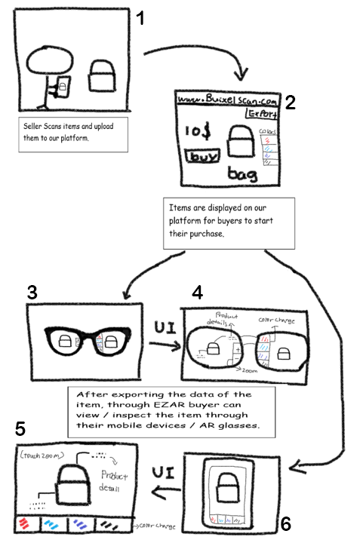

*Figure 1 to 2. shows how sellers can scan and upload their products.*

*Figure 3 to 4. showcases EZAR UI on AR goggles.*

*Figure 5 to 6. showcases EZAR UI on mobile devices.*

# Illustrations

## How to use Buixel as a Seller?

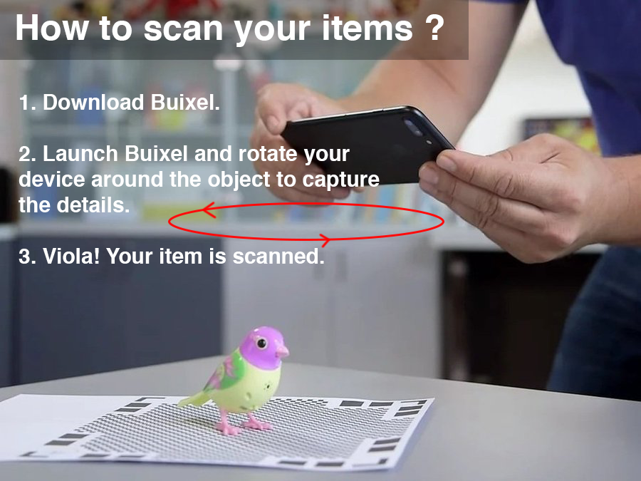

*Buixel* allow sellers to capture and scan their products. *Buixel* will be able to scan the product and capture even the smallest of detail in high quality.

## How to use Buixel as a Buyer?

# 

Products that have been scanned with the *Buixel* will be available when purchasing from different shopping platforms online and buyers can view the products with the *Buixel* app.

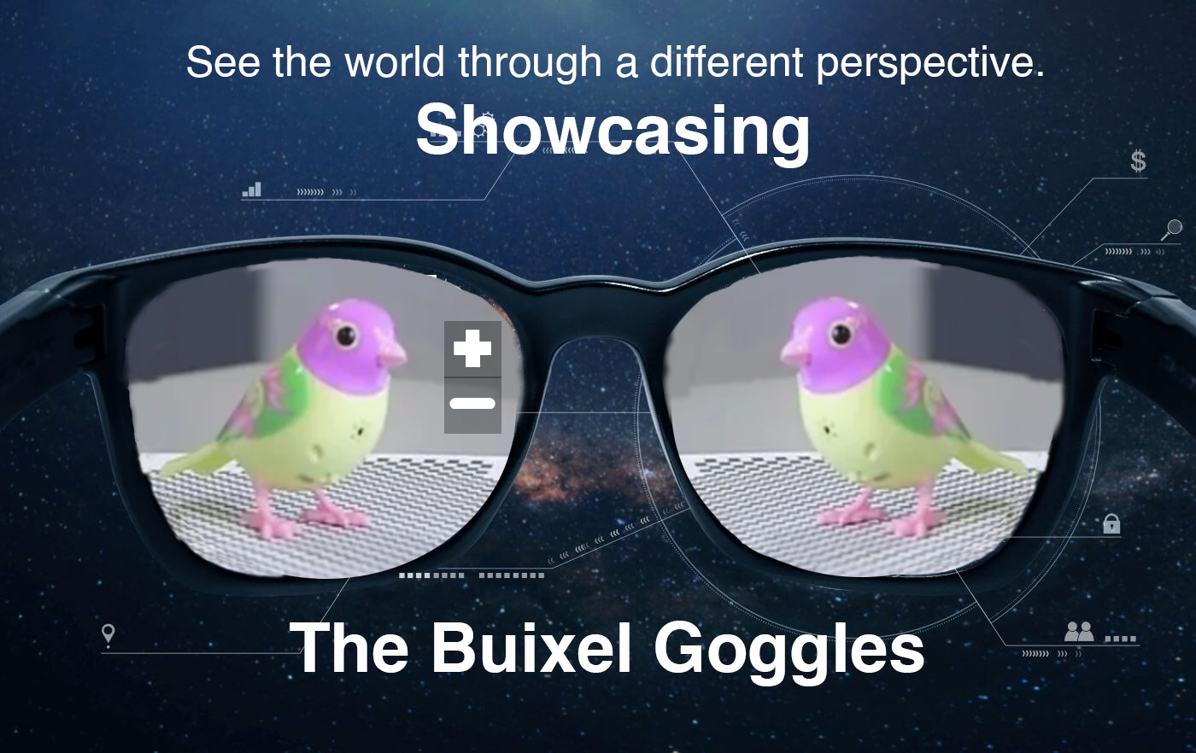

Products can be viewed through either home devices *(Smartphones*) or

with the *Buixel* goggles.

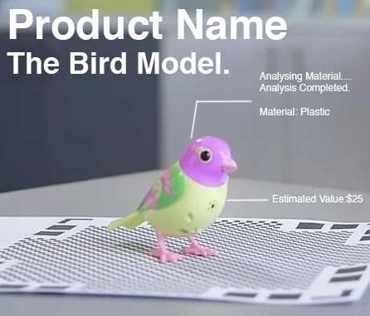

*Figure 7. Details that can be seen with the Buixel Goggles*